Difference between apache Spark and Apache Beam:
 | Apache beam | Apache Spark
Description | A unified programming model. It implements batch and streaming data processing jobs that run on any execution engine(multiple execution engines). It executes pipelines on multiple execution environments. | Spark is a fast and general processing engine compatible with Hadoop data. It can run in Hadoop clusters through YARN or Spark's standalone mode, and it can process data in HDFS, HBase, Cassandra, Hive, and any Hadoop InputFormat. It is designed to perform both batch processing (similar to MapReduce) and new workloads like streaming, interactive queries, and machine learning.
Compute engine(Processing) | Due to the unified model, processing is carried out in the same way for both batch and stream data. | Two different APIs for batch/stream data processing. You need to split data yourself by grouping by the time and it is not truly real-time processing, as basically Spark divides the data stream into micro batches of X seconds called Dstreams, which is a sequence of RDDs under the hood.
Category | Workflow manager | Big data tool
GCP | Dataflow  - Dataflow due to its serverless nature we didn’t need to set up a cluster each time we wanted to process data.  - The next big advantage of Dataflow is the Shuffle service, which addresses the shuffle issue on Spark executors as it moves heavy operation out of the worker virtual machine to the service backend.  - Besides, there is autoscaling out-of-the-box, Streaming engine for streaming pipeline support. Generally, Dataflow is supposed to be a self-managed platform, so less effort is required to configure it compared to Dataproc.  - Logs from workers and metrics are displayed on the same UI and are available even after the job is finished. | Dataproc  - Dataproc has autoscaling feature, but it requires more actions: creating autoscaling policy in GCP and integrating it into the job. Moreover, to achieve good performance we needed to play a lot with Spark configuration like tuning memory on workers, choosing appropriate number of shuffle partitions, executor instances and so on.  - Dataproc does not keep the history of metrics once the cluster is shut down. You need to spin up a separate Spark history server to collect them and then configure its visualization in GCP Monitoring.

Resources:
https://beam.apache.org/documentation/sdks/python/
https://beam.apache.org/documentation/programming-guide/

Difference between GCP Cloud dataflow and Dataproc:
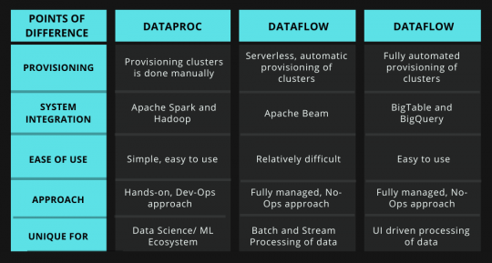
https://wisdomplexus.com/blogs/dataproc-vs-dataflow-vs-dataprep/
Features | Dataproc | Dataflow
 | - Cloud Dataproc is a managed Spark and Hadoop service that lets you take advantage of open-source data tools for batch processing, querying, streaming, and machine learning.  - Cloud Dataproc provides a Hadoop cluster, on GCP, and access to Hadoop-ecosystem tools (e.g. Apache Pig, Hive, and Spark); this has strong appeal if already familiar with Hadoop tools and have Hadoop jobs  - Ideal for Lift and Shift migration of existing Hadoop environment  - Requires manual provisioning of clusters  Consider Dataproc  - If you have a substantial investment in Apache Spark or Hadoop on-premise and considering moving to the cloud  - If you are looking at a Hybrid cloud and need portability across a private/multi-cloud environment  - If in the current environment Spark is the primary machine learning tool and platform  - In case the code depends on any custom packages along with distributed computing need | - Google Cloud Dataflow is a fully managed, serverless service for unified stream and batch data processing requirements.  - When you run a job on Cloud Dataflow, it spins up a cluster of virtual machines, distributes the tasks in your job to the VMs, and dynamically scales the cluster based on how the job is performing. It may even change the order of operations in your processing pipeline to optimize your job.  - When using it as a pre-processing pipeline for ML model that can be deployed in GCP AI Platform Training (earlier called Cloud ML Engine)  - None of the above considerations made for Cloud Dataproc is relevant.  - Interesting concrete use case of Dataflow is Dataprep. Dataprep is cloud tool on GCP used for exploring, cleaning, wrangling (large) datasets. When you define actions you want to do with your data (like formatting, joining etc), job is run under the hood on Dataflow.  - Cloud Dataflow also offers the ability to create jobs based on "templates," which can help simplify common tasks where the differences are parameter values.  - Use Dataflow on pubsub to transform your data and let it write rows into BQ. You can monitor the ETL pipeline straight from data flow and use stackdriver on top. Stackdriver can also be used to start events etc.  - Use autoscaling to minimize the number of manual actions. Basically when this solution is setup correctly, it doesn't need work at all.
Provisioning | Manual provisioning of clusters | Serverless. Automatic provisioning of clusters
Hadoop Dependencies | Dataproc should be used if the processing has any dependencies to tools in the Hadoop ecosystem.
Portability |  | Dataflow/Beam provides a clear separation between processing logic and the underlying execution engine. This helps with portability across different execution engines that support the Beam runtime, i.e. the same pipeline code can run seamlessly on either Dataflow, Spark or Flink.

https://www.linkedin.com/pulse/gcp-dataflow-vs-dataproc-kumar-p
